Lumina Tutor: Project structure for the professor
@Afzal Manihar
Lumina Tutor is an adaptive AI tutor that builds a lesson from a source document, teaches it, and hands a stuck student to a human teacher.

At a glance
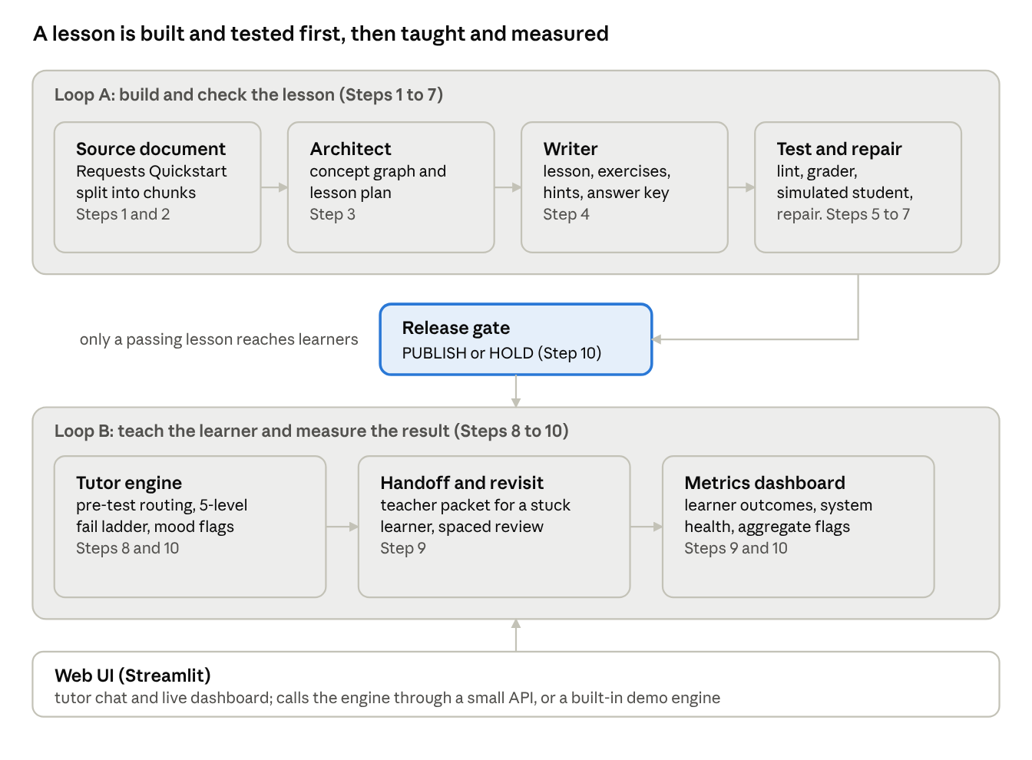
system overview · 2 loops, 1 release gate
A source document becomes a tested lesson in Loop A. Only a lesson that passes the release gate goes to Loop B, where the tutor teaches, hands over stuck learners and reports metrics.

The problem and the idea
The system rests on two ideas.
- Build the lesson from a source, and test it before any student sees it. Every exercise links to a chunk of the source document. A simulated student tries the lesson, a repair loop fixes what fails, and a release gate decides PUBLISH or HOLD.
- React when a learner is stuck. The tutor reads error patterns, answer speed and hint use, tries up to five different treatments, and then hands the learner to a person together with a report.
The lesson design follows Gagné's nine events of instruction (a fixed 21-minute template) and Merrill's five first principles.

The ten steps
Steps 1 to 7 build and check the lesson (Loop A). Steps 8 to 10 teach the learner and measure the result (Loop B). Each step ends with its own PASS or FAIL checks.
Step | Loop | Component | What it does
1 | A | Setup | Connects to Groq, splits the source document into chunks, holds the configuration
2 | A | Data schemas | Strict Pydantic models for Blueprint, Exercise, AnswerKey, FailureLog and LearnerState; the mastery rule as code
3 | A | Blueprint agent | Builds the concept graph and prerequisites, plans each lesson on the 8-slot, 21-minute template, checks Merrill's principles
4 | A | Writer agent | Writes lesson text, exercises with 3 hints and 4 variants, a worked example, the hidden answer key and source links
5 | A | Lint and grader | 12 pacing rules, a sandboxed code runner and a grader that uses the hidden answers
6 | A | Simulated student | Plays the lesson like a learner and writes failure logs
7 | A | Repair loop | Repairs the lesson from the failure logs, keeps the best version, writes a handoff packet
8 | B | Tutor engine | Pre-test routing, fail ladder, same-mistake shortcut, mood flags, teach-back
9 | B | Handoff, revisit, aggregate | Park and handoff packet (encrypted, learner id pseudonymised), spaced revisit, a flag when 30% of learners fail an exercise twice
10 | B | LangGraph, gate, dashboard | State machine that pauses and resumes, release gate, metrics dashboard, saved sessions

How the tutor handles a stuck student
Each failed attempt on an exercise moves the learner one level up the ladder. Level 5 ends the struggle by bringing in a person.
Level | Treatment | What the learner sees
1 | Hint, then a new variant | A small nudge and a fresh question on the same skill
2 | Worked example and completion problem | A similar solved example, then a half-solved task
3 | Backward diagnostic | Quick questions on the prerequisite idea
4 | New representation and teach-back | Tiny steps, an analogy, then "explain it in your own words"
5 | Park and handoff | Progress is saved and a teacher takes over
Rules behind it:
- Mastery means two correct answers on two different variants of the same exercise.
- The same mistake twice skips straight to the level-3 treatment.
- A correct answer with a weak explanation is treated as a rote answer and is not counted as mastery.
- Very fast wrong answers, slow wrong answers and heavy hint use each get a different tutor message and update the learner's mood flags.
- A parked exercise blocks only the parts that depend on it. The learner continues with the rest, and the parked exercise returns for review the next day.

The web UI and how it connects to the engine
The UI is one Streamlit file (app.py) with custom HTML, CSS and JavaScript for a dark, glass-style look. The screen is split in two: the tutor chat on the left, and on the right a live dashboard with the fail-ladder level, student mood, error signals, handoff status and the spaced-revisit schedule. Two more tabs show system metrics and the LangGraph node trace.
The app can talk to two backends and picks one automatically.
 | Hosted demo | Live engine
Where it runs | Streamlit Community Cloud | Google Colab, in the same session as Steps 1 to 10
What it teaches | A hand-written sample lesson | The real lesson built from the source document
Logic | A small built-in engine with the same ladder rules | The real Step 8 tutor inside the Step 10 LangGraph
Connection | None needed | A small local API (the bridge) wraps the LangGraph app; the UI calls it
Status badge | Yellow "Demo engine" | Green "Live engine connected"
Best for | Opening the link at any time | A full live demo of the real engine

Current status and honest limits
Steps 1 to 10 are built and each finished with its checks passing. The limits below are stated up front so nothing in the demo is misread.
- One source document so far. The input is the Python Requests Quickstart. The architect split it into 11 concepts (3 assumed prerequisites, 8 taught) and planned 4 lessons, L01 to L04.
- L01 is the lesson run end to end. It is fully written, checked and used by the live tutor. L02 to L04 are planned; the same pipeline will write them.
- The hosted link teaches a sample lesson. That lesson is hand-written for the demo, not generated by the language model.
- Dashboard cohort numbers are synthetic. They come from scripted learners run through the same graph, not from real students.
- No pilot with real learners yet. Learner outcomes such as retention and transfer need real data.
Next steps:
- A topic library, so a learner can pick a topic (for example machine learning) and start that lesson. Each topic needs its own source document.
- Upload your own document and have a lesson built from it.
- Host the live engine permanently instead of in a Colab session.

Technology and links
Area | Tools
Language models | Groq: gpt-oss-120b writes the lesson, gpt-oss-20b plays the simulated student
Orchestration | LangGraph (state graph that pauses for the learner, with saved checkpoints)
Data and checks | Python, Pydantic v2 schemas, networkx for the concept graph, a sandboxed Python runner
Privacy | Learner ids are pseudonymised and handoff packets are encrypted
Metrics | pandas, matplotlib, SQLite for saved sessions
Web UI | Streamlit with custom HTML, CSS and JavaScript
Links:
- Live demo: lumina-tutor-agent.streamlit.app
- Code: github.com/AfzalManihar/lumina-tutor-Agent

